Unit Testing Screenshot

## Customer Details Input Page

Test Case: Invalid Name

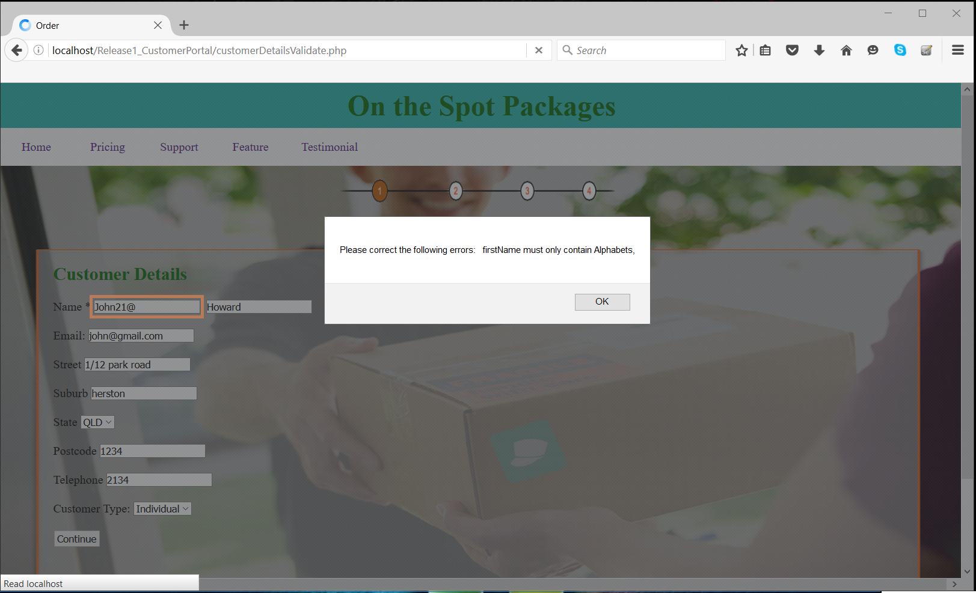

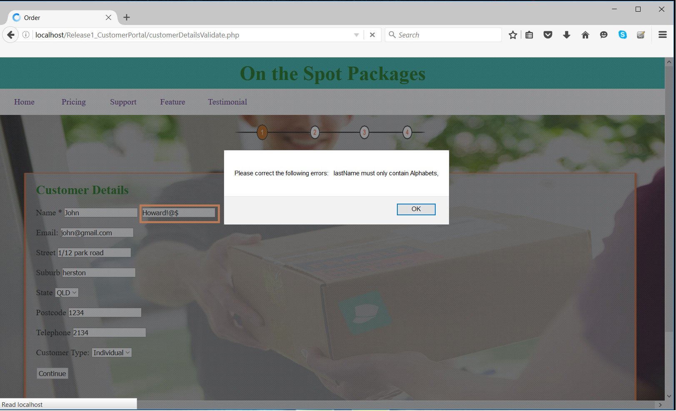

Test Case: Invalid Email

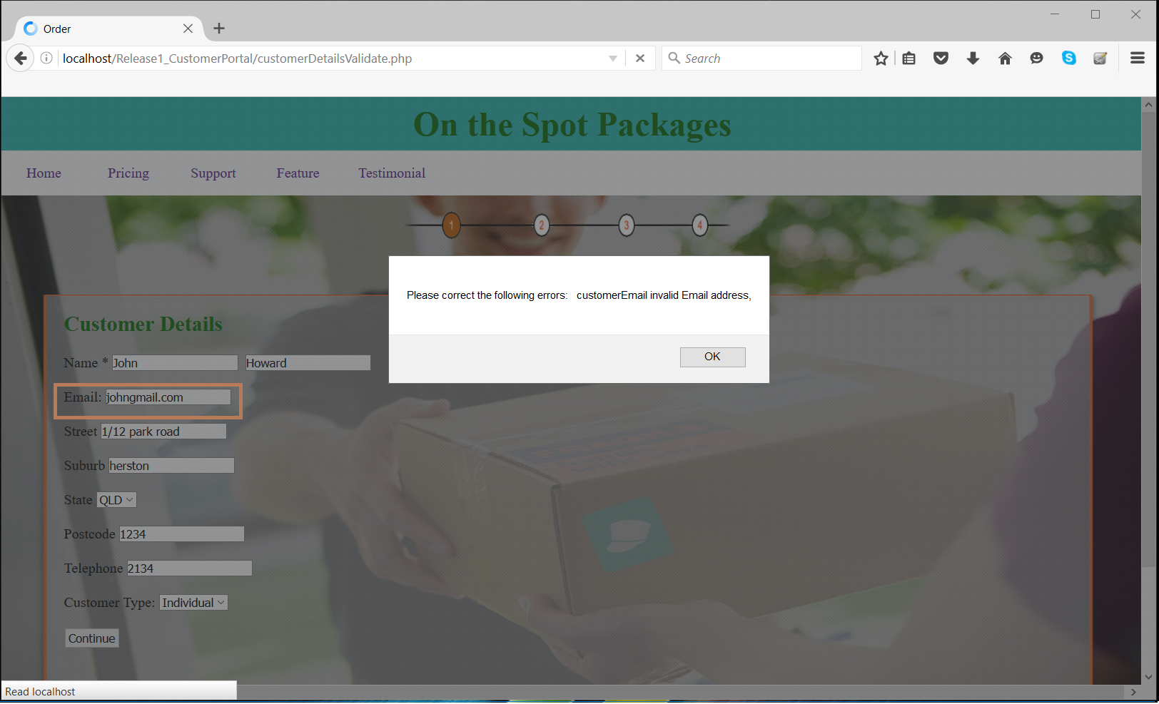

Test Case: Invalid Postcode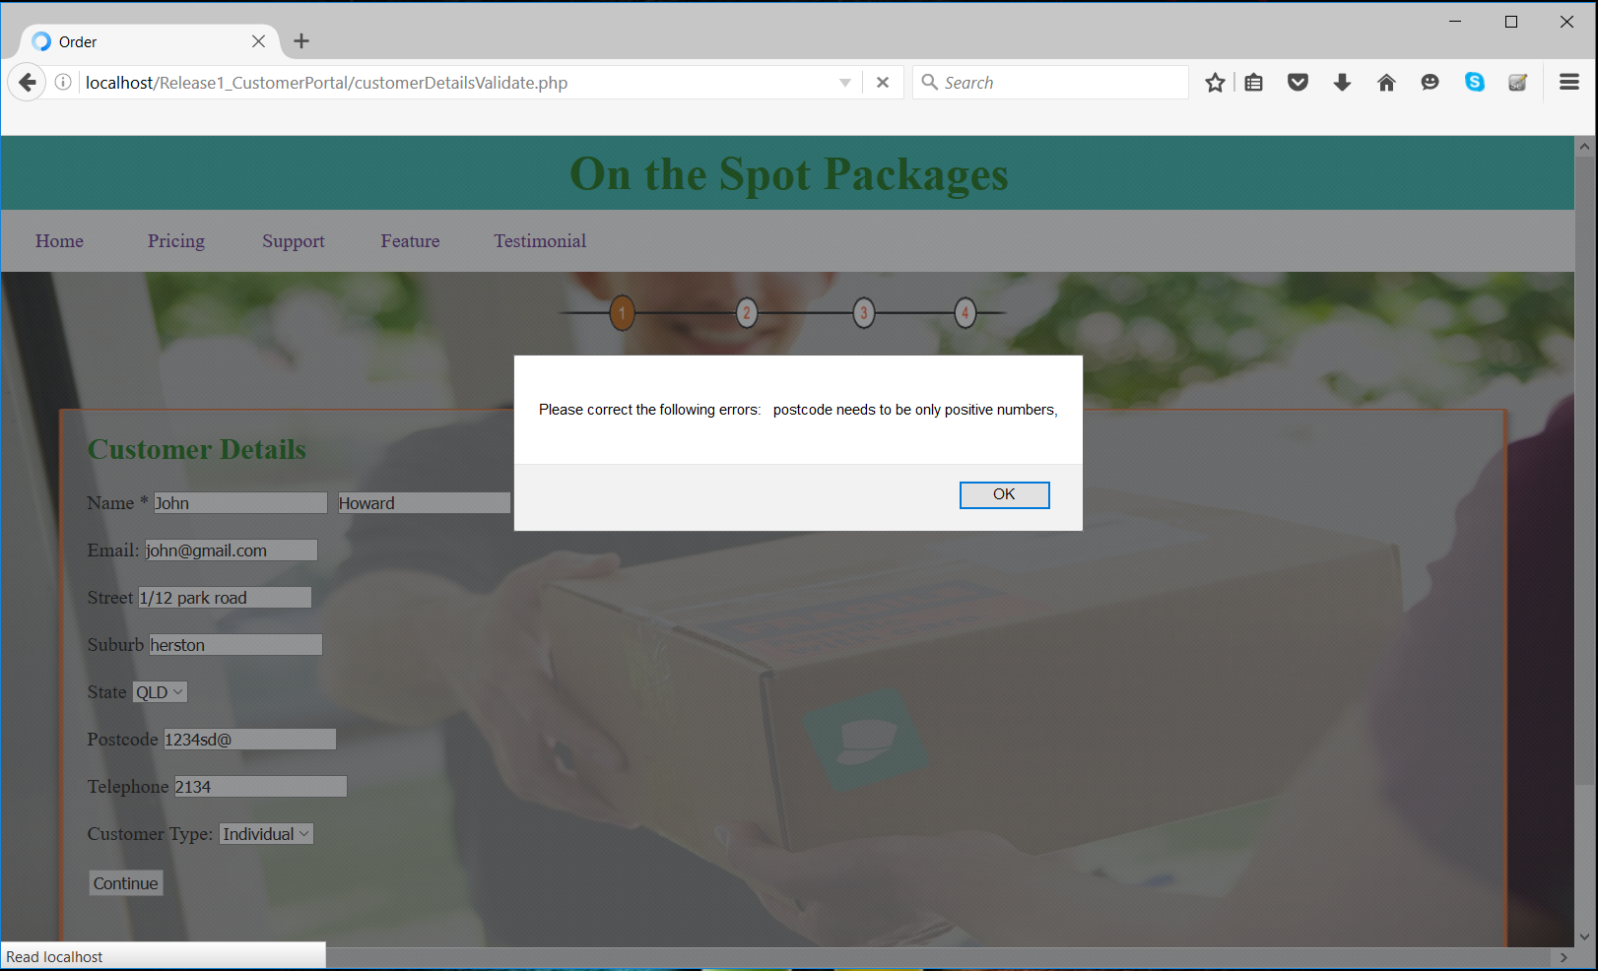

Test Case: Invalid Telephone Number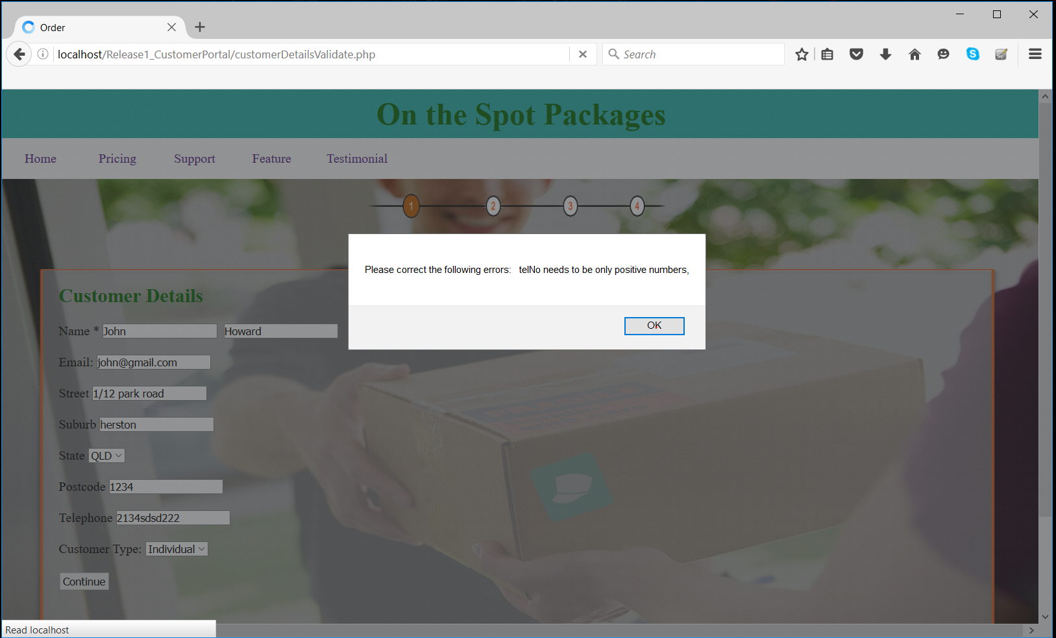

Test Case: Leaving a field blank

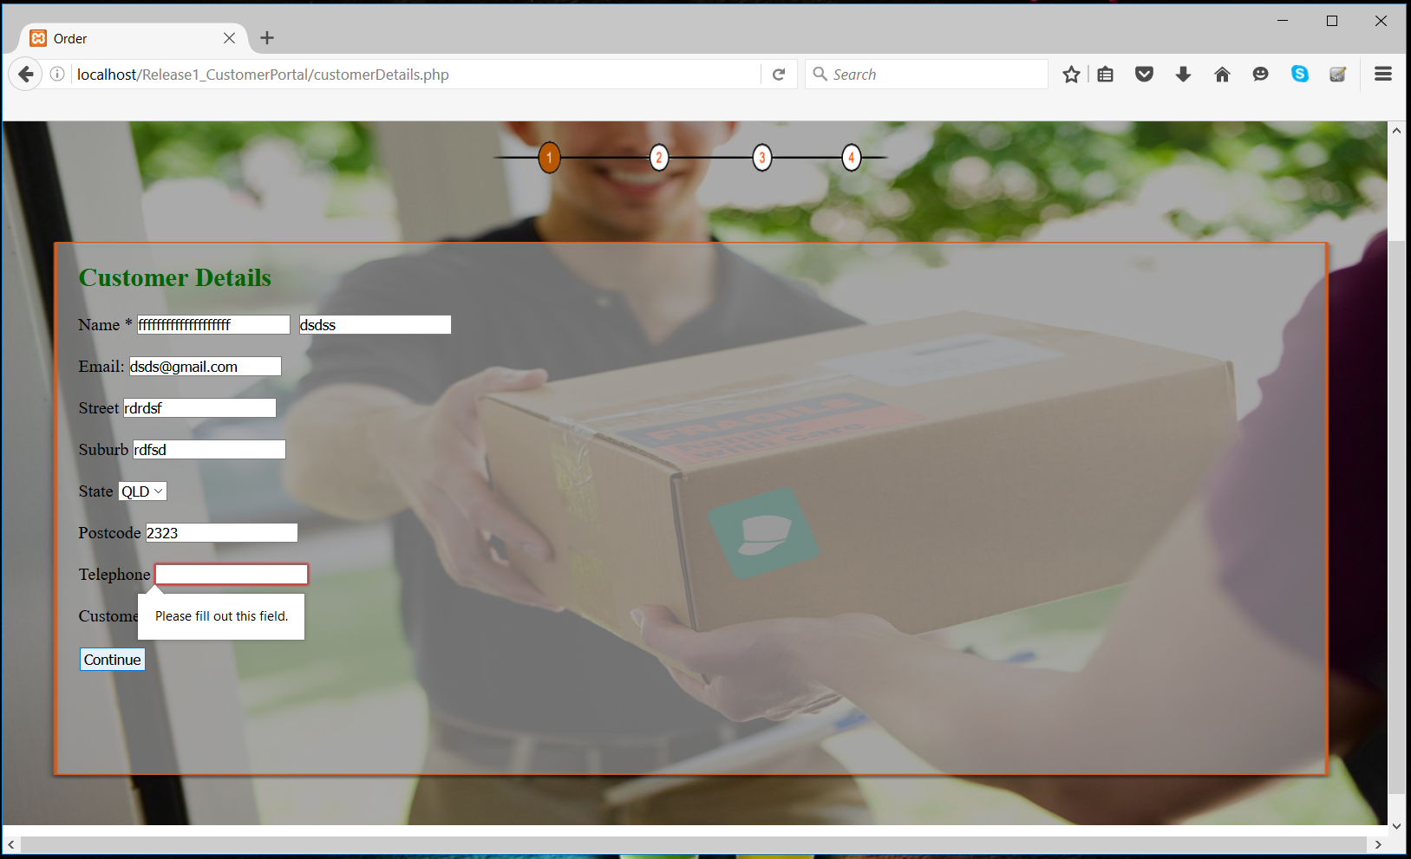

## Order Details Input Page

Test Case: Invalid Package Number

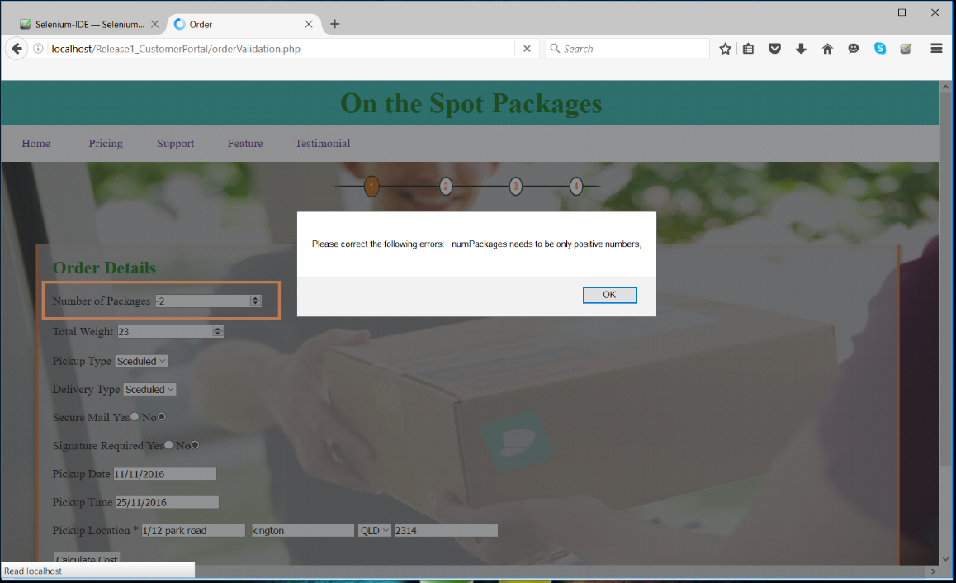

Test Case: Invalid Total Weight

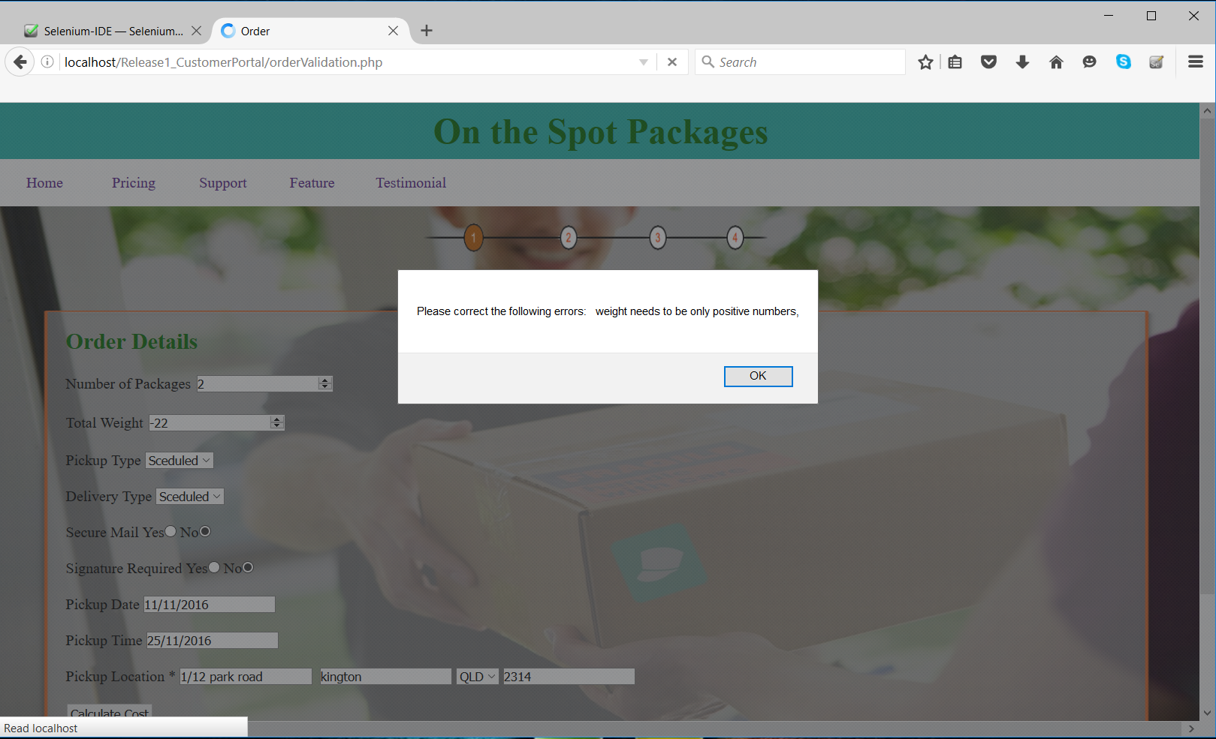

Test Case: Invalid Postcode

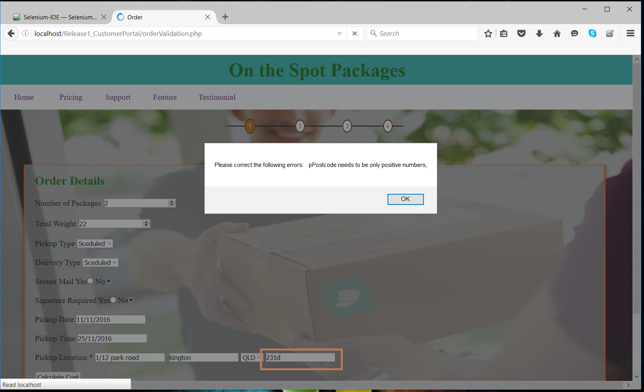

Test Case: Incomplete form (missing Number of Packages)

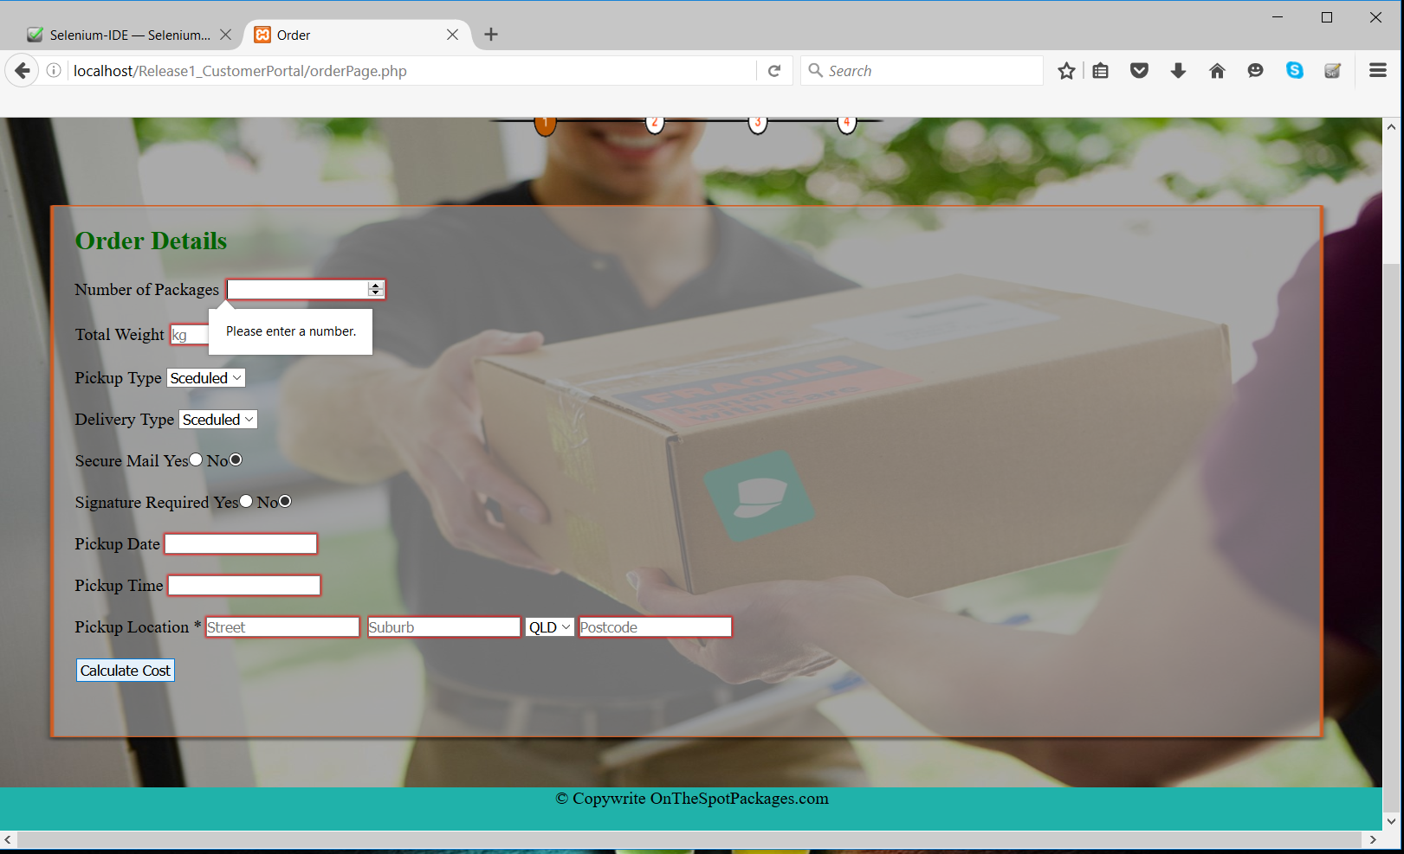

Test Case: Incomplete form (missing total weight)

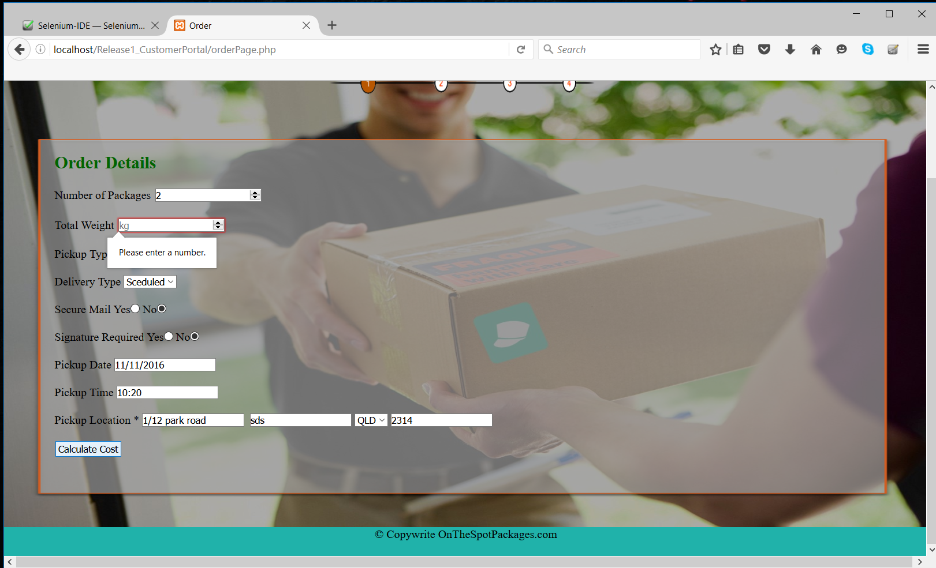

## Delivery Details Input Page

Test Case: Invalid Recipient Name

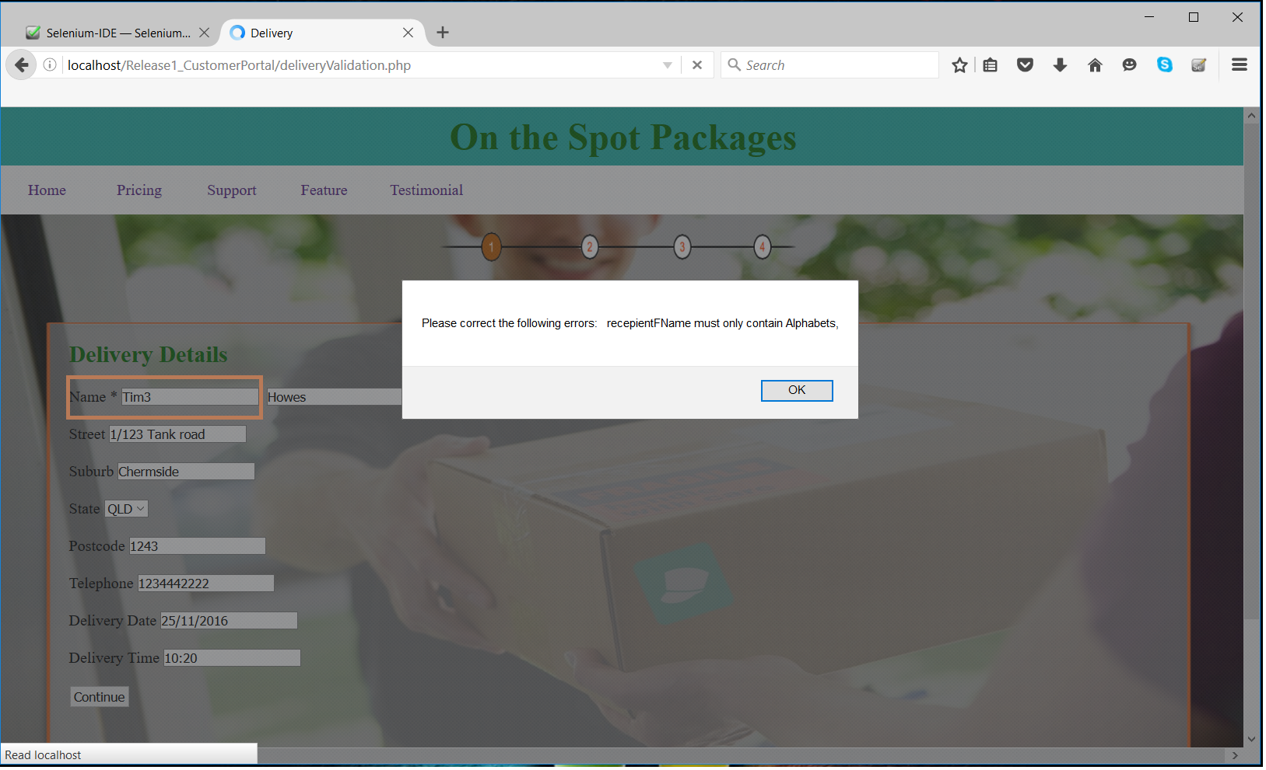

Test Case: Invalid Recipient Name

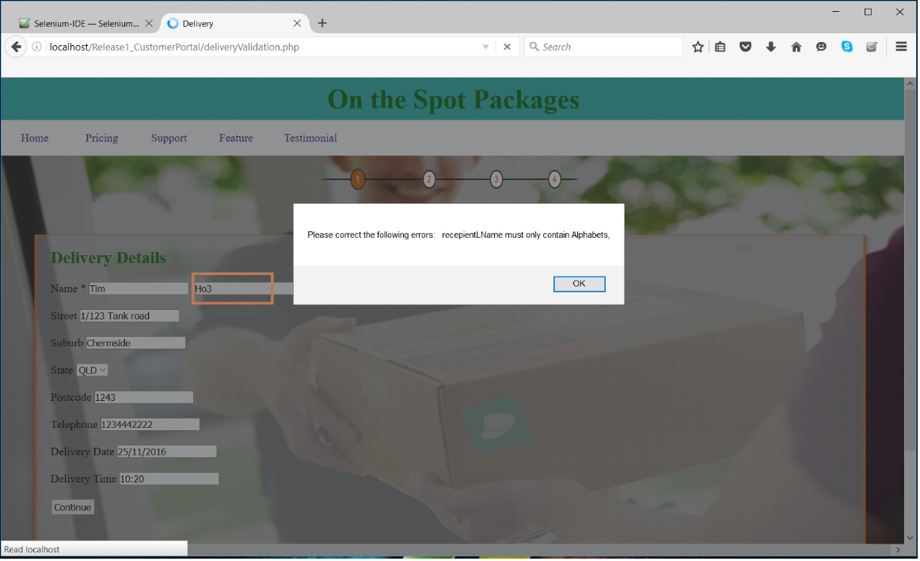

Test Case: Invalid Postcode

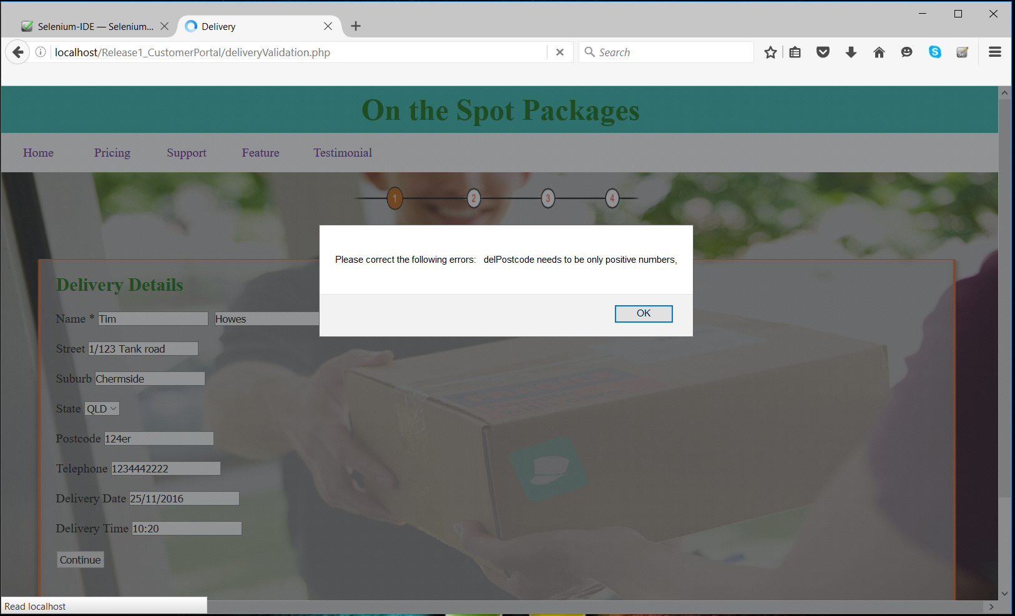

Test Case: Incomplete data

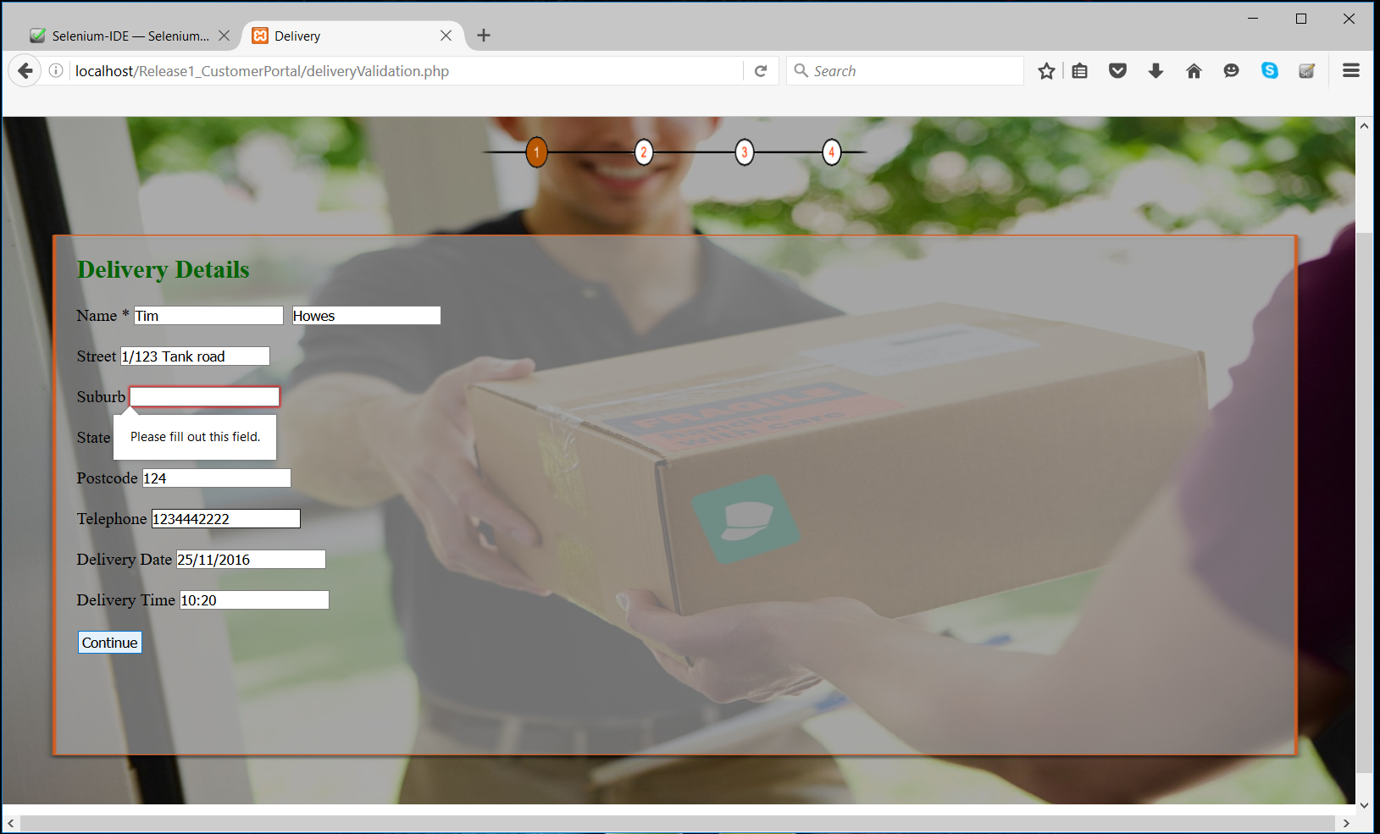

## Track Page

Test Case: Incomplete form (missing Order ID)

